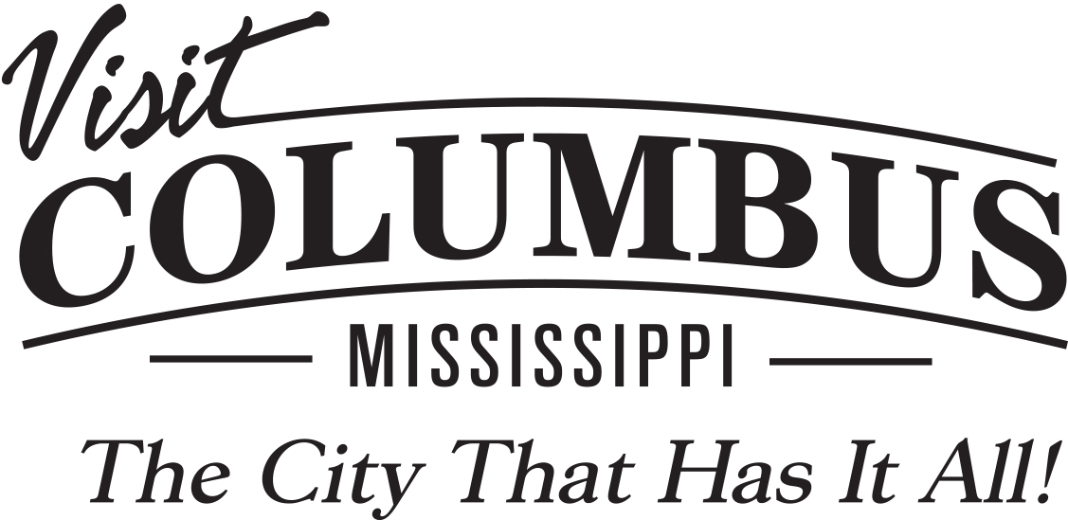
For More Information:
Nancy Carpenter, CEO
nancy@visitcolumbusms.org
800-920-3533

In The City that Has It All,
going all out, and all in, for recreational fun.

He uses spinner baits and plastics, attracting his catch from hot spots dense with water willows. She uses plastic, too, at the nearly dozen hot spots for shopping spread across the city. And at the end of the day, after they’ve taken a leisurely and romantic stroll on the scenic Columbus Riverwalk, the setting sun shimmering on the surface of the Tennessee-Tombigbee Waterway, the couple compares their hauls and their happy adventures to their supreme satisfaction.
With all due respect to other destinations, Columbus, “The City that Has It All,” isn’t just for lovers, it’s for lovers of all kinds, including lovers of romance and lovers of recreation.
Of course, that means there are plenty of male visitors who enjoy Columbus shopping, and avid female “fishermen” trawling the waters and coming up with impressive catches on the 9,000-acre Columbus Lake on the Tenn-Tom Waterway. Because when it comes to great play, this is a city that works from every angle, and for every angler—not to mention boaters, golfers, hunters, hikers, runners and outdoor lovers of all ages. And that’s because “The City that Has It All” goes all out, and all in, when it comes to recreational options.

Fun for every angler, revved up recreation from every angle:
Take the Columbus Lake: While the powerful logistical assets of the Tenn-Tom have helped attract global industry to the area, the Lake’s beautiful waters and plentiful bass stocks have also drawn anglers from across America both for national tournaments and just-for-fun fishing days in the sun—of which there are a multitude here in the heart of the Deep South.
Plenty of sunshine and sunny hospitality, plus a raft of great recreational options on land as well as water, have made Columbus the perfect kid-friendly family destination as well. At the 190-acre Plymouth Bluff Environmental Center, the history runs as deep as the bluff rises high, providing dramatic views and a gorgeous setting for the four miles of nature trails ideal for hiking or simply enjoying outdoors that are truly great.

MORE
ADD PAGE 2 – OUTDOOR AND RECREATION

More inviting trails and lush wildlife await at the Lake Lowndes State Park and Opossum Trail, where fishing is excellent on the 150-acre lake and where the facilities are also fine for football, tennis and softball. Camping, under the stars or in an RV, makes for family-friendly adventures as well, at Dwayne Hayes Recreation Area and Campground, and the Tombigbee River RV Park. Parents can pass on their passion for hunting at the Black Prairie Wildlife Management Area and Burnt Oak Lodge, while kids and canines go crazy for the fun at Propst Park, where amenities include disc golf and Bark Park: In The City that Has It All even the family dog has fun.
Elite and recreational runners are also having the time of their lives, and great times in their races, at the Spring Pilgrimage Half Marathon & 5K Run, and the Possum Town Triathlon, a USA Triathlon-sanctioned event. Want to kick up your speed? Try the .3-mile oval red clay track at the Columbus Speedway or the .373-mile oval at Magnolia Motor Speedway. Or while away an afternoon of splendor on the grass at the superbly managed public courses at the Lion Hills Club and Whispering Pines. Then savor your score with a great meal at Lion Hills or at any of the city’s exceptional eateries and restaurants. Superb dining and shopping are also reasons why the Columbus Soccer Complex has become a preferred location for regional and local play. Game facilities are tucked in a wooded location just steps away from Main Street Columbus and connected via the city’s scenic Riverwalk that winds around the edge of the Tenn-Tom—one more reason that visitors can bank on great recreation even if their favored sport is competitive shopping.
The first childhood home of Pulitzer-Prize winning playwright Tennessee Williams now serves as the Columbus Welcome Center, and that seems appropriate in a place where “play’s the thing.” In the city that goes all out, and all in, visitors can be assured of fun from every angle.

###

